TABLE OF CONTENTS

Page Number
1. Introduction 1
1.1 About 1
1.2 Users 1
1.3 System Requirements 1
2. Getting Started 2
2.1 Home Page 2
2.2 Log In 3
2.3 Create New User 3
3. Browse Cards 4
3.1 Site Navigation 4
3.2 Search Query 4
4. Create Card 5
4.1 Title num
4.2 Title num
4.3 Title num
5. Generate File 7
5.1 Title num
5.2 Title num
5.3 Title num
6. Modify Card 9
6.1 Title num
6.2 Title num
6.3 Title num

7. Edit Image 12
7.1 Title num
7.2 Title num
7.3 Title num
8. Troubleshooting 15
8.1 Title num
8.2 Title num
8.3 Title num

Introduction

About
Midwestern State University Card Services is a program designed to combined Midwestern State University student identifications with their respective Wells Fargo® banking account. In coordination with Wells Fargo®, students are able use their card as their Midwestern State University identification card and as a Wells Fargo® banking/debit card.
This website is designed to provide Midwestern State University Card Services administrators with an easy-to-use graphical interface. All functionalities of this website meet all requirements of the users and administrators. These requirements include: create a student identification card, generate a new student profile, modify existing student profile, edit image of student profile, and browse all existing student profiles.

Users
The users of this website are the employees and administrators at the Midwestern State University Information Desk and the faculty member in charge of the development of this website. The users will interact with the system to complete all functional requirements. The users are the primary actors in all use cases for this website. The primary actors are those who interact with the system on a daily basis and with the customer. The daily users include the student assistant at the information and the full-time employees of the Midwestern State University Information Desk.

System Requirements
Administrators and users of this website are encouraged to access this website through the following web browsers: Google Chrome version 56.0.2924.76 or later, Mozilla Firefox 51.0 or later.

Getting Started

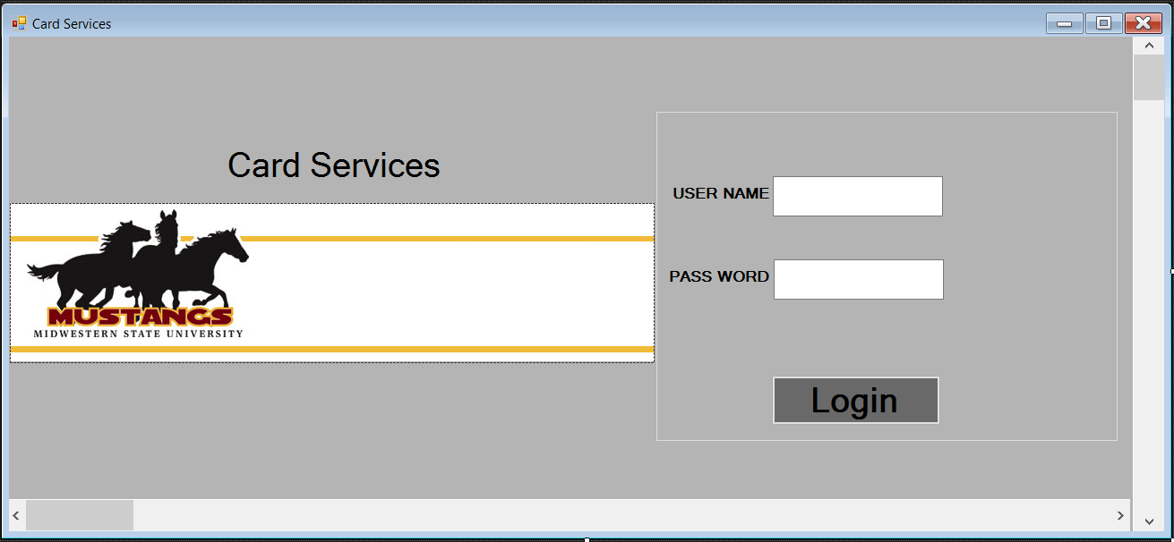

Browse Cards

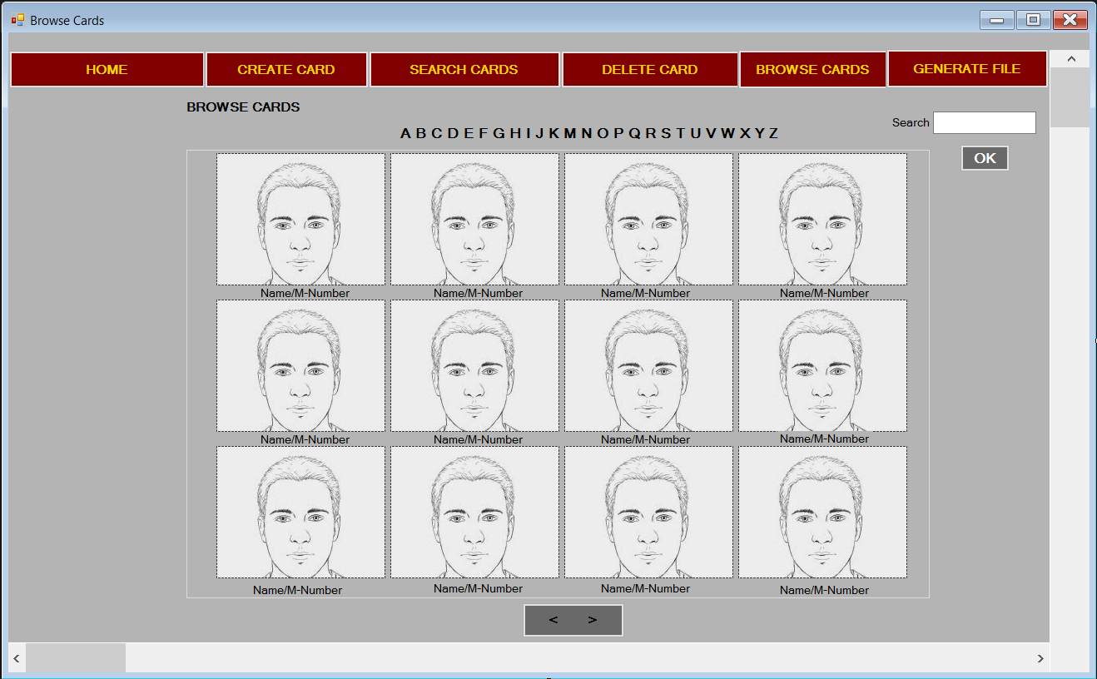

Create Card

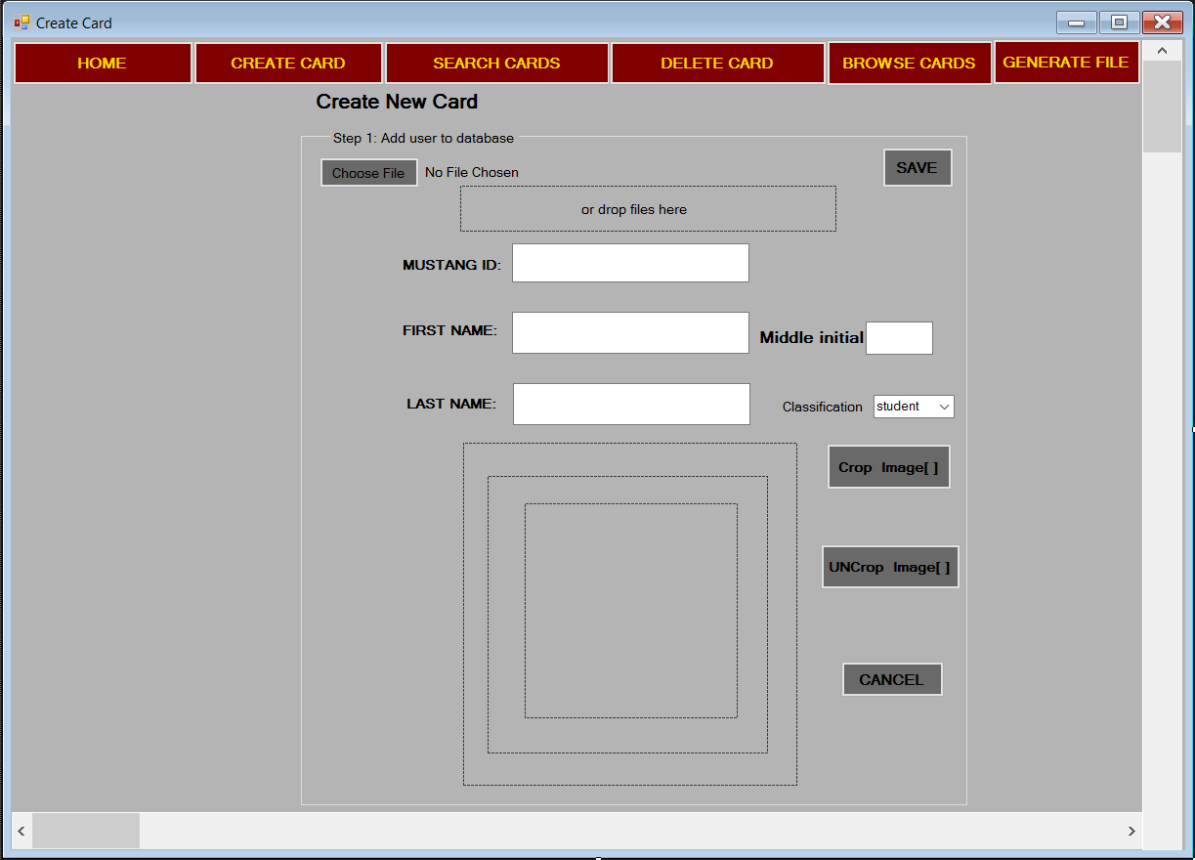

Generate File

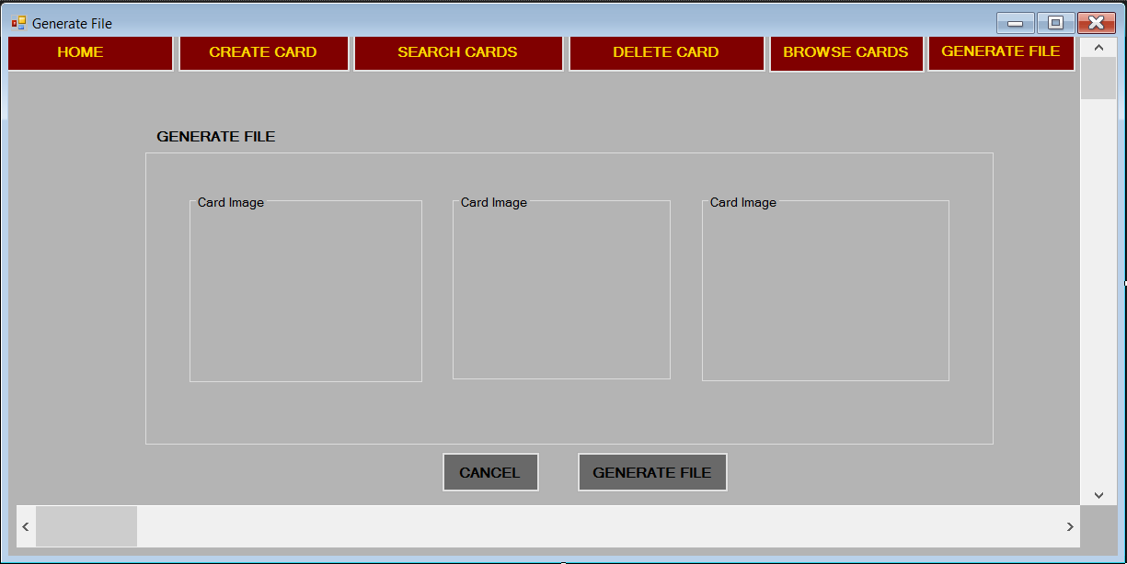

Delete Card

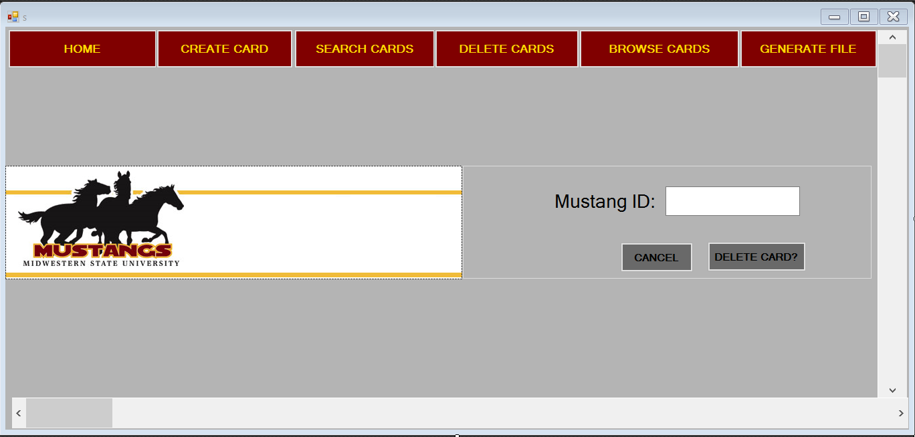

Edit Image

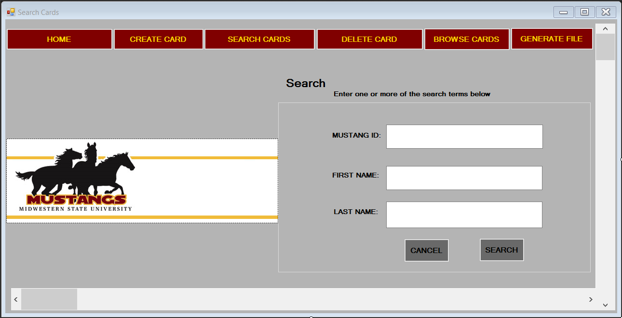

Troubleshooting

